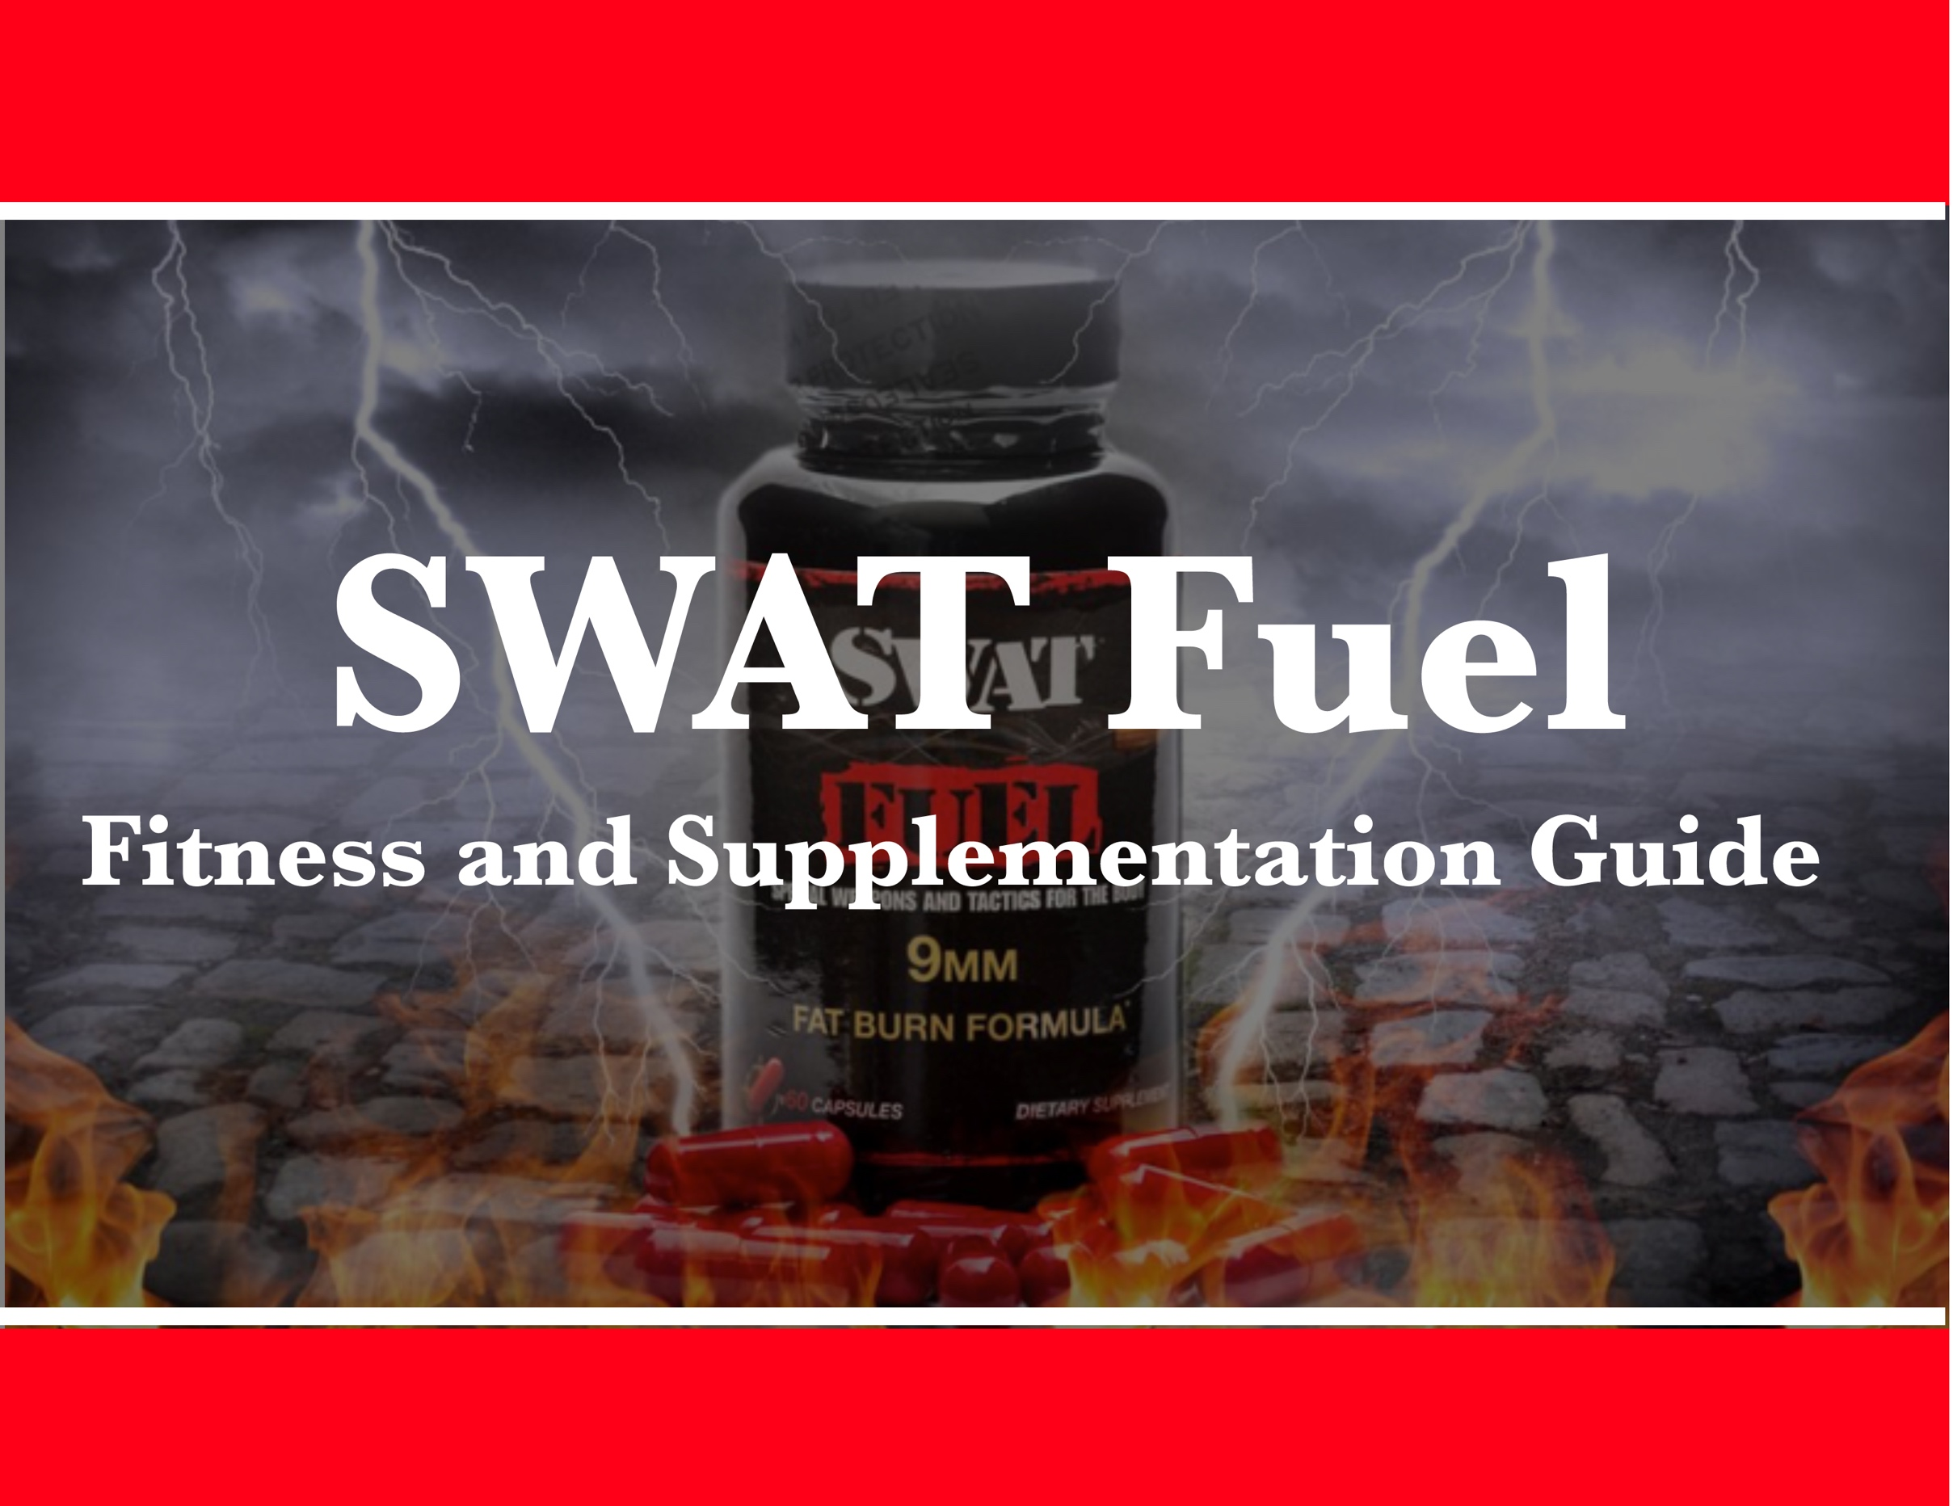
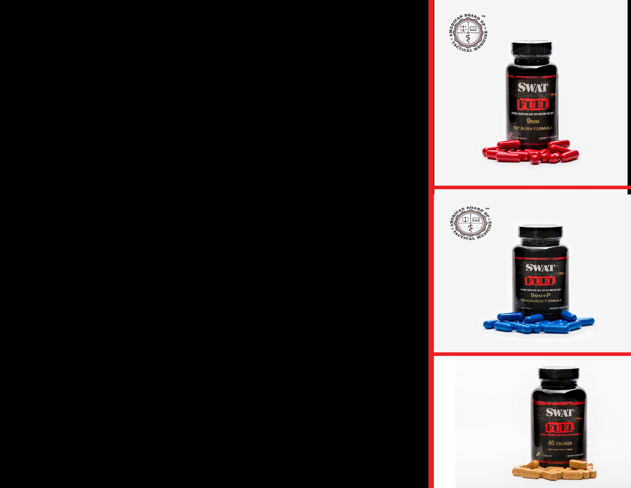
Table of Contents
Introduction 3
SWAT Fuel and Supplementation Guide
Sleep 5
Mindset 6
Exercise 7
Rest 9
Diet 10
Bio-Hacking 11
SWAT Fuel 40 Caliber Multivitamins 15
SWAT Fuel 9 mm Series Products
9mm Fat Burn Formula 16
9mm+P Endurance Formula 17
Protein supplementation 18
Hydration 19
Manufacturer 20


Introduction

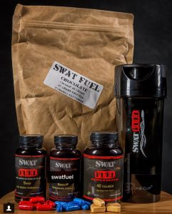

SWAT Fuel supplements were originally formulated with the help of SWAT, Army Green Berets/82nd Airborne, Navy Seals, Air Force PJ’s and Marine Recon/MARSOC operators.

We learned a lot from these guys and we want to teach you some of what we learned.


Sleep
1
- Sleep before 3:00 a.m. is the most restful sleep. At about 3:00 am, your body has a normal spike in cortisol, the major stress hormone of the human body.

Physiologically, it starts the waking process and your sleep is not as restful afterwards. Ideal sleep hours are from 9:00 pm to 04:30 or 6:00 am.

- Try and sleep in 90 minute blocks, e.g. - 1.5, 3, 4.5, 6, 7.5 or 9 hours. Add how long it takes you to fall asleep onto the front end.

Mindset
2

- Fitness starts in your mind. Nobody can tell you to do it and it just happens. The only person who needs to decide to become fit is you. You have to set your own goals, set a real plan, and start believing in yourself.

At SWAT Fuel, we advise getting up on the scale every day as a gut check. If you do not check the scale, you will drift in the wrong direction, most likely. It also helps you to realize what foods are hurting you and setting you back. You have to be honest with yourself. When you get on the scale and you have gained 3 lbs., it is not all fat.

Some of the gain is water retention, most likely from carbohydrates or sodium. Look at your trend, not at the individual numbers. Remember to believe in yourself and to set long-term and short-term goals. Every day you stick to this, you are becoming healthier than you were yesterday. That is the whole principal of OPTIMIZING HUMAN PERFORMANCE.



Exercise
3
- Exercise is important but we need to make sure you do the right exercise and in the right amounts. Doing too much, too soon will set you back.

- If you're a couch potato, start with a real workout one day during the 1st week, then 2 days during the 2nd week, then 3 days during the 3rd week. You will recover from your soreness and will notice that your recovery times rapidly shorten. With proper supplementation and diet, you will also be able to do more very quickly.
- Once your exercise regimen reaches 3 days a week, stay there for a while. Increase the intensity of your workouts so that you’re really hitting it hard. We recommend 1 day on, 1 day off, and not exercising 3 days in a row.

- Cardio, Yoga and Strength Training:

- You want to do cardio. On your workout days, strongly consider doing at least 30 minutes of cardio. It will keep your endurance up, which will help in any life-threatening situation. Regardless of your background, endurance training has a practical application. You never know when disaster or misfortune will strike. In addition, cardio training will also help you burn off calories that would otherwise turn to fat. If you trying to lose excess weight, cardio training, in general, is key. If weight loss is your particular goal, Fasting/Fasted Cardio, exercise after 8 hours of no food intake, is the quickest way to access your fat stores and increase your endurance.
- Yoga/flexibility training is paramount in keeping your joints and muscles in good shape long-term. If you do not stretch, you will become stiff and immobile. It is strongly recommended to do this on your days off from cardio/weight-training.
- Strength training with weights or Cross-Fit is the best way to exercise your muscles and individual muscle groups. You probably have a picture in mind of what your ideal body would look like. If you lift weights in your training regimen, chances are that you will not end up looking like a hard-core body builder. That particular physique requires massive commitment and specific targeting of muscle groups. You may also consider working with a personal trainer. A personal trainer knows how to target specific muscles, and helps you attain aesthetic, strength, and performance goals. If you are looking, specifically, for aesthetics, be honest with yourself and make sure your plan or your trainer takes you there.

Follow a strength training routine that fits the body morphology or the performance you are looking for. In other words, if you want a swimmer's body, you need to train like a swimmer. If you want to look like a professional body builder, you need to train like one. If you want to look like an underwear model, you need to train like they do. Look at the Cross Fit body as a blend.


Rest
43
- Your body repairs itself while you rest. If you do not have adequate rest, your muscles and ligaments will be damaged and, rather than getting better, they will just be repairing as you continue to damage them.

Do not do too much, too quickly, as you step-up your fitness program. Allow for adequate rest each day, as well as rest days in between your workouts, until you become more fit. As far as knowing how much to rest, be sure to get enough sleep at night. Your body repairs itself the most at night, when you sleep. If you are really sore before you go to bed, consider adding a slow-burn protein for night-time repair, or BCAA's. But remember, you may put on weight as fat if you ingest calories before sleep. It is hard to shrink and grow at the same time. Get on the scale, and see what it does in the morning.


Diet
543
- Calories

- Calories used to be the main focus of diet and physical training. To some extent, calories-in should balance calories-out. But this formula is complicated by the fact that not all calories are the same. Carbohydrate calories, for example, are utilized by the body very differently than calories from fat and protein. They affect growth hormone and insulin differently.

In addition, your physical training determines how the calories are used and whether your body uses them to store fat. Carbohydrates can fuel your work out, but if you have too many of them, the body will simply store excess carbohydrates calories as fat. Even long distance runners and marathoners can get fatter if they overdo energy gels and carbohydrates while training. Increased blood sugar and blood sugar spikes cause insulin to be released. Once insulin is released, the body is takes those calories and stores them as fat. So the calorie theory is not so simple. The answer to this calorie question is to learn about bio-hacking and to use this hack.

Bio-hacking
6543
- Sugar/Starches


- If you are doing a lot of physical work throughout the day or are a military operator, chances are you will be burning lot of calories. This is also true if you are trying to maintain your body temperature in the cold.

Carbohydrates help you maintain energy. If you eat too many of them at one time, however, your blood sugar will rise and insulin will then be secreted.

Carbohydrates are best consumed in smaller amounts and more frequently, calculated based on your physical activity. If you're not going to burn them off, stay away from them.

- Fats

- If you are doing a lot of physical work throughout the day or are a military operator, chances are you will be burning lot of calories. This is also true if you are trying to maintain your body temperature in the cold.

- Grass-fed butter
- Coconut oil
- Olive oil
- MCT (medium chain triglyceride) Oil

- Protein

- Fast absorb recovery protein is typically a mix of branched-chain amino acids and whey protein. Whey protein is one of the most abundant and easily available proteins on the market. They typically come in a Whey Concentrate or Whey Isolate forms.

At SWAT Fuel, we manufacture grass-fed, grass-finished, organic, non GMO Whey Concentrate. In our studies, it was preferred and worked better than whey isolate. Even if you are lactose intolerant, in some cases, the isolate may be more tolerable for you. We found that our particular form of Whey Concentrate is extremely well tolerated and all natural. Our muscle recovery formula and should be taken 20-30 minutes’ post workout and will repair your muscles for about 2-3 hours, preventing protein catabolism. This is where your body will break down a different muscle group to repair the muscle groups you just worked out. For example, if you work out your upper body and the muscles need to be fed, they will steal protein from your legs, where the muscle is plentiful, to try and repair your upper body.

- Slow absorb protein is typically from food sources and is more complicated to break down. These proteins are typically available to the body to use to repair and feed your muscles and cells about 3 hours after. Egg whites, casein protein, fish, beef, bison, chicken, wild game and shellfish are great sources. Make sure they are hormone-free, grass-fed or wild caught. Make sure you time a post workout meal with protein, so that the nutrients are available when the recovery protein wears off.

- Fiber

- Fiber is plant material that is typically not digestible. It helps retain water in the colon which prevents constipation. Eating low residue and high-protein diets can really make you constipated and give you bowel disease (Most commonly diverticulosis and diverticulitis). Fiber is good to have in your diet because it will keep your gut running normally. It also helps maintain good bacteria in your gut biome.

- Supplementation

- Your body is very efficient at extracting nutrients from your food until about the age of 25, the age when you stop growing. After this, your body starts to age and becomes less efficient long before your skin gets saggy and your muscles start to atrophy.

The principal behind anti-aging medicine is to keep your body running in peak physical performance for as long as possible. One of the ways we help anti-aging is through supplementation in order to make it is easier for your body to assimilate nutrients, especially after age 25. Supplementation before the age 25 makes you realize your full potential more quickly. It also helps to maintain peak physical performance.

- Inflammatory foods

- Typically, processed food is high in chemicals and inflammatory substances. This is BAD for you. Stay away from processed food and cook your own food. It does not have to be difficult or complicated. If your food item has a label in the grocery store, you should probably stay away from it. People who are

really into fitness tend to “meal prep” a couple times per week, and eat only what they prepare. That’s why they look and feel so good. Think about doing this at some level.

- Gut Biome

- This refers to the bacteria in your gut. If you have been on antibiotics or eating a lot of low quality foods, you probably have an overgrowth of either yeast or the wrong bacteria in your gut. You should probably supplement for about 6 months with high-quality probiotics to get your gut biome in better shape. By supplementing with probiotics, the good bacteria will outgrow the yeast and the bad bacteria, which are wreaking havoc on your system.


76543
SWAT Fuel 40 Caliber Multivitamins
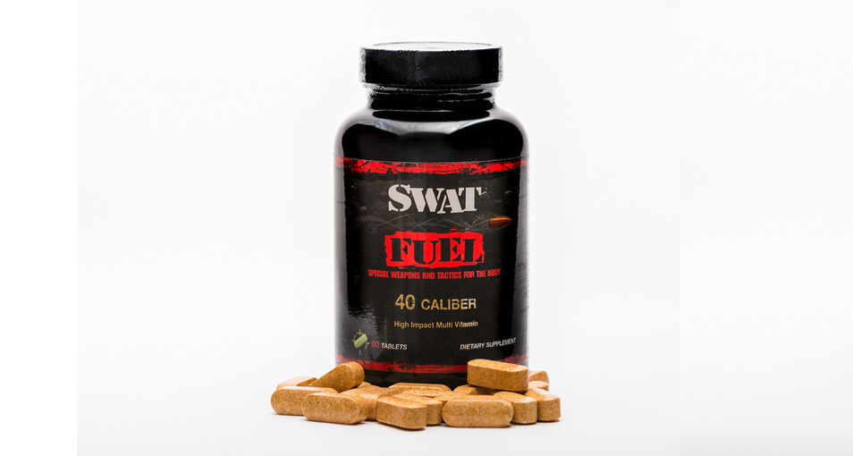
- Micro-nutrients are difficult for the body to extract from food when you're eating it. Presenting top quality, extremely clean supplements to your digestive system makes it easy for these micro-nutrients to be absorbed. As a result, your body will run much more efficiently and you will be less hungry. In other words, you will have less cravings because your body is not hungry for these nutrients. You will end up eating less. Multivitamins increase the nutrient density of your food. This helps you stay healthy, fit, and lean.

876543
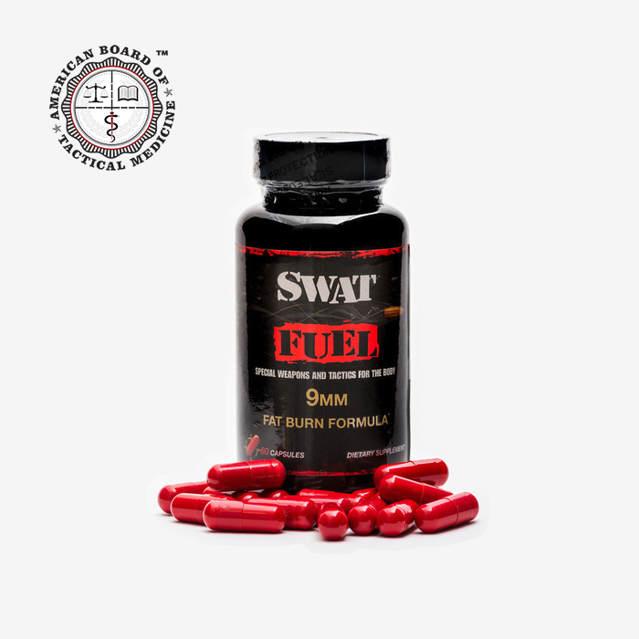
SWAT Fuel 9 mm Series Products
- 9mm Fat Burn Formula

We combined a pre-workout, energy and fat burn formula into 1 easy-to-use capsule. There is nothing to mix, and it is super light-weight and compact.

This formula increases the ability of your body to utilize fat as a fuel source and it is a true thermogenic fat burn supplement. Be sure to hydrate well and you will notice that you really sweat much more than usual. If you are a military or law enforcement operator, we recommend only using this formula for training, not for operational use.

With regular exercise, you will reach your weight goal much faster than without it. Work harder and smarter!

- 9mm+P Endurance Formula
In the 9mm+P Endurance Formula, we replaced the green tea extract found in 9mm with bitter orange extract. This allows the formula to be used operationally. Because this formula is focused on endurance, it works really well as a pre-workout. It will not overpower your sympathetic nervous system so you will notice no jitters and no crash.
Our proprietary 9mm+P formula was specifically designed to be able to use in life or death situations. 9mm+P Endurance Formula is the only energy formula based on Stress/Combat physiology. It is designed to combat parasympathetic backlash, which is very dangerous in life threatening situations. No other formula has ever been designed with this purpose in mind. This makes it particularly useful for special operations groups. Thanks to the work of lieutenant Colonel David Grossman, the problem was identified and SWAT Fuel formulated the solution. The 9mm+P Endurance Formula can be used in any life-threatening encounter to maintain your strength, stamina, mental focus and to combat deadly parasympathetic backlash.

976543
Protein supplementation
- Fast absorb recovery protein SWAT Fuel 44 Magnum Protein Powder
- Slow absorbing protein
- Branched chain amino acids




Hydration
10976543

- Hydration is an extremely important component in your program. SWAT Fuel typically recommends not drinking your calories if you can avoid it. Soda, alcohol, or any kind of prepared drinks are generally not good for you. Unless you are using a specific hydration formula aimed at electrolyte replacement during physical activity, you probably do not need the extra calories.

We recommend drinking water, unsweetened tea or black coffee. One very interesting note about water and hydration: Hunger is very frequently confused with thirst. If you think you're hungry, drink a glass or two of ice water. You may notice that in 15 minutes your hunger completely goes away.





SWAT Fuel Supplements are manufactured
in CGMP and NSF certified.

